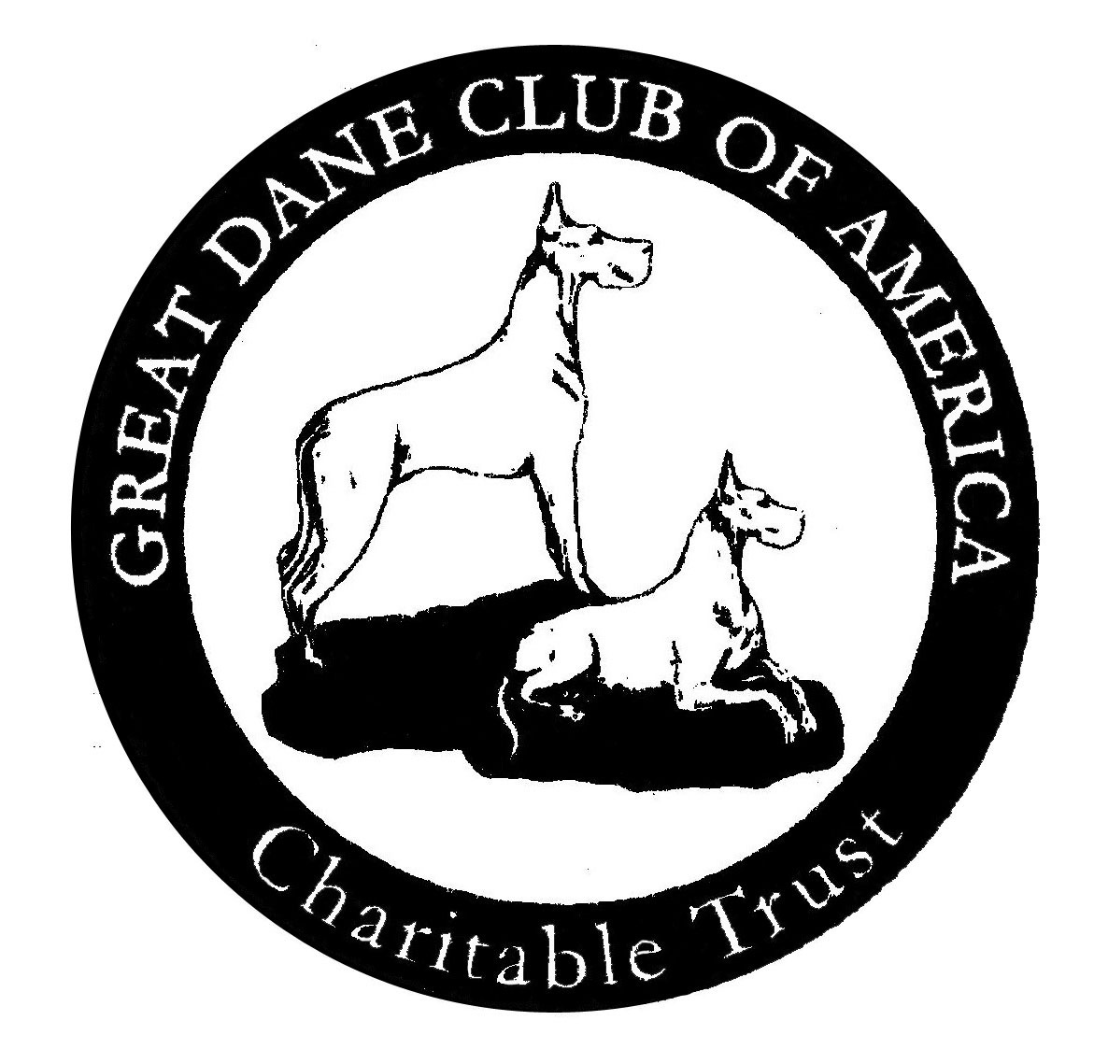

Great Dane Club of America Charitable Trust
Disaster Relief Fund Application

Name _________________________________________________________________________________________

Address ______________________________________________________________________________________

City/State/Zip Code ________________________________________________________________________

Email ________________________________________________________________________________________
Phone _______________________________________________________________________________________

Are you a member of the GDCA or an affiliate club? Please specify.

Are you a Rescue or a private party?
Describe the nature of your emergency and date of occurrence:

Do you have insurance coverage for this loss?

What help is needed?

Are you displaced? If so, estimated length of displacement
How many Great Danes are involved? List names and ages.

How many other animals? Please list types and names:

Please outline any additional information that will allow us to make a determination of your qualification for assistance and your overall need.

I hereby affirm that all the above stated information provided by me is true and correct to the best of my knowledge.

Applicant Signature _____________________________________________________ Date _______________________

Incomplete applications or applications that do not meet eligibility criteria will not be
considered.

Each request will be individually reviewed and a determination of what, if any, assistance will be provided will be made in a timely fashion. Payments may be made directly to service providers rather than to individuals depending on the scope and type of assistance sought. A recommendation based on your application will be made to the CT and the CT will vote on the final amount to be provided.

Please send the completed application to:
Cathy Schaefer, Trustee, P.O. Box 521, Acton, CA 93510 or
email to: dickschaefer@gmail.com

