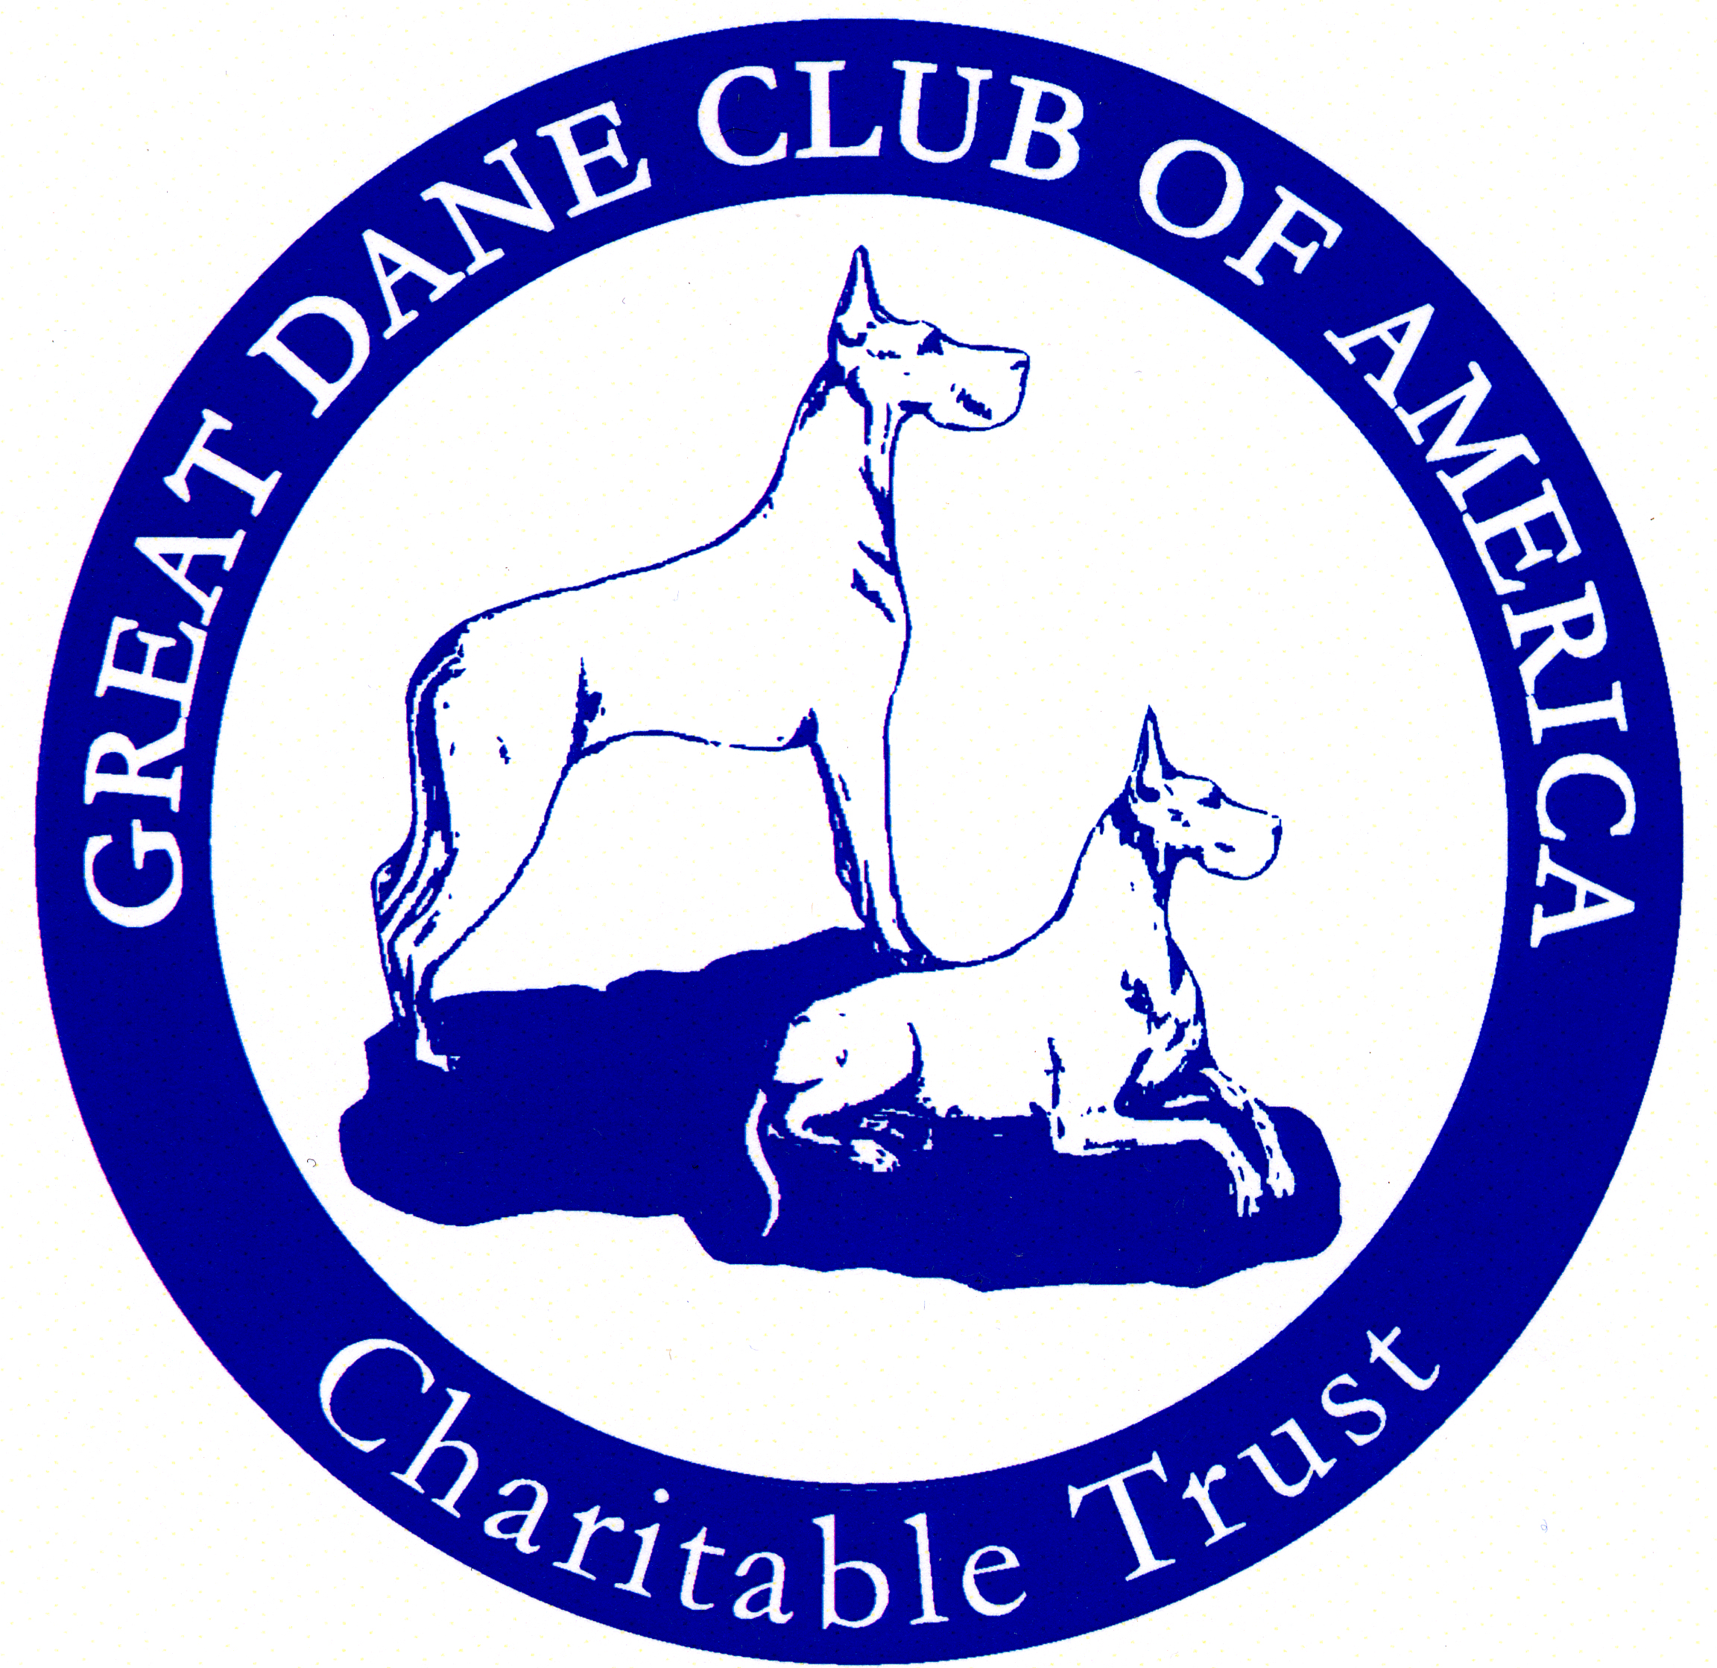

OFA Echocardiograms Subsidized by the GDCA Charitable Trust

We are pleased to announce that the Great Dane Club of America and the Great Dane Club of America Charitable Trust are continuing the $75 reimbursement for echocardiograms for GDCA and Affiliate Club members for exams performed in 2023. Guidelines for participating are listed below. We would like to thank Darryl Pitts for taking the helm as the gatekeeper for this program.

- The GDCA Charitable Trust will reimburse (subsidize) OFA advanced cardiac (echocardiogram) studies for GDCA and Affiliate Club members in the amount of $75.
- Limited to ONE PER DOG PER YEAR.
- Great Dane must be one of the seven acceptable colors as recognized by the breed standard.
- Echocardiograms performed at GDCA National will be excluded as they are already subsidized and offered at a reduced rate to participants.
- Send a copy of receipt, OFA application and mailing address for receipt of check to Darryl Pitts at ECHO.GDCA@gmail.com. If you are not a GDCA member, please indicate your affiliate club membership.
- Processing of checks will be done quarterly. We would appreciate it if you could be timely in cashing your checks. Thank you.

